Lola’s Calculus Travels!

Meet Lola! She is a spunky girl who loves mathematics. Her parents are world travelers, and they decided to take some time off to travel the world. Lola is super excited, but also sad because she couldn’t study calculus at school. Being the good Samaritan that you are, you offer to teach Lola calculus as she travels so she can continue her beloved math studies!



Lola is on board with this super cool idea! She wants to master one calculus topic during each visit to a different country! She refuses to leave to country until she has learned all of the material successfully,. Each visit to a country takes one day, but if you get a question wrong on the “Lola tries” problems, you must stay an extra day! Your challenge is to be back to North Carolina in 120 days, the earlier the better, in time for Lola’s cousin, Dora the Explorer’s birthday!



Lola loves to play hide and seek, and so she will be hidden in certain places throughout the manual! See how many times you can find her. Yes, you can count the Lola on this page as the first time you see her! The amount of times Lola is in the whole manual will be posted at the end of the Answer Key at the back!

Table of Contents

Welcome to North Carolina! 3

Guided Practice 4

Lola Tries 4

Welcome to Mexico! 5

Guided Practice 6

Lola Tries 6

Welcome to Costa Rica! 7

Guided Practice 8

Lola Tries 8

Welcome to Panama! 9

Guided Practice 10

Lola Tries 10

Welcome to Brazil! 11

Guided Practice 13

Lola Tries 13

Welcome to Peru! 14

Guided Practice 15

Lola Tries 15

Welcome to Argentina! 16

Guided Practice 17

Lola Tries 17

Welcome to South Africa! 18

Guided Practice 19

Lola Tries 19

Welcome to Madagascar! 20

Guided Practice 21

Lola Tries 21

Welcome to Kenya! 22

Guided Practice 25

Lola Tries 25

# Welcome to North Carolina!

What is a limit?

**The limit (L) of a function, f(x), as “x” approaches “a” refers to the behavior of the function as x-values get closer and closer to the values “a”. We do not care what actually happens at x=a, just the behavior of the graph as we get closer and closer to it. It is mathematically written as . This limit only exists if and . L would be your y value. This basically means that the limit from the left (a-) must equal the limit from the right (a+) for the limit to exist. Let’s investigate this idea further!

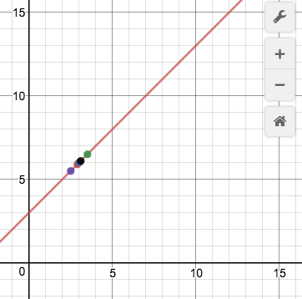 This is the graph of the function, . Let’s see what happens to the behavior of the function as we approach the x-value of 3 on this function from the left. We can look at a point somewhat close to x= 3 from the left, at x=2.5. In this case, the coordinate would be (2.5,5.5). But, we can do even better! What about at x=2.9? The coordinate for this point would be (2.9, 5.9). We can choose x values closer and closer to 3, without ever actually reaching it. In fact, there are an infinite number of numbers that get awfully close to the coordinate at x=3, (3,6), without ever touching it. This helps us determine the behavior of the graph as we get closer and closer to x=3 from the left. The y coordinates for x=2.5 and x=2.9 are getting closer and closer to a y value of 6, which would mean that the

Great! We are halfway done. To find the overall limit, we must also look from at the behavior as x approaches 3 from the right. Let’s choose a number that is a bit larger than 3, x=3.5. The coordinate would be at (3.5, 6.5). If we chose an x-value a little closer, perhaps at x=3.1, our coordinate would be (3.1, 6.1). Again, as we get closer and closer to x=3, our y value is getting closer to 6. This means that the . Since the limit from the left equals the limit from the right, we know that the . Again, we do not care what the actual coordinate is at x=3, just what the behavior of f(x) is from either side of x=3.

## Guided Practice

1. What does mean? What does mean? Does the overall limit exist?
   1. As x-values get closer and closer to the 1 from the left, the function f(x) is getting closer and closer to 2. As x-values get closer and closer to 1 from the right, the function f(x) is getting closer and closer to 3. The overall limit does not exist because the limit from the left does not equal the limit from the right!
2. The function is shown on the right. What is the ?
   1. 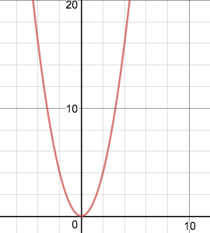To determine the limit, we would look at the behavior of the graph as we choose x-values closer and closer to x=0. First, we would have to look at the limit from the left. If we chose an x-value a bit smaller than 0, perhaps x=-.1, the y-value would be .01. If we chose an x-value to the left of x=0, but a little bit closer, perhaps x=-.001, the y value would be .00001. The y-values are getting closer and closer to 0, so . Now, we must look at it from the right. If we chose an x-value a bit larger than 0, perhaps x=.1, the y-value would be .01. If we chose an x-value still to the right of x=0, but a little bit closer, perhaps x=.001, the y-value would be .000001. The y-values are getting closer and closer to 0, so . Since the limit from the left equals the limit from the right, we know that .

## ../Desktop/Screen%20Shot%202016-11-10%20at%2010.50.25%20AM.pngLola Tries

1. What does mean?
2. Does the exist if and ?
3. What is the ? The graph of g(x) is shown on the right.

**Next Stop: Mexico**

# ../Desktop/mexico2.jpgWelcome to Mexico! *../Desktop/mexico1.jpg*

Bienviendo a Mexico!

How do I evaluate limits from a graph and a table?

Now that we understand what a limit is, it’s time to start looking at how to evaluate limits using graphs and tables. As a reminder, a limit is the behavior of a function as x approaches “a”. With this in mind, we are ready to start!

|  |  |
| --- | --- |
| x | f(x) |
| .9 | 1.09 |
| .99 | 1.99 |
| 1.1 | 2.01 |
| 1.19 | 2.1 |

What is the Well, to evaluate the limit, we must look at the behavior from both sides of x= 1. As x-values get closer and closer to 1 from the left, the y-values are getting closer to 2. The same is true from the right! So we know that the because of this. That’s pretty easy right? Well, let’s look at a harder example. 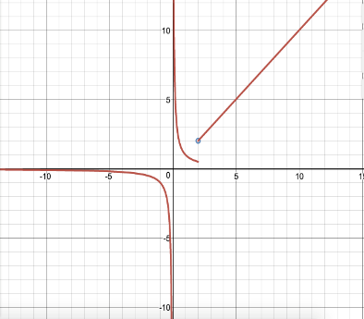

|  |  |
| --- | --- |
| x | f(x) |
| 2.5 | 2.9 |
| 2.9 | 2.999 |
| 3 | 5 |
| 3.5 | 2.999 |
| 3.9 | 2.9 |

What is the At first glance, you would probably think that this limit evaluates to 5. Think again! Yes, f(x)=5, but the the . This is because a limit doesn’t care about the behavior at a point, but rather the behavior around a point. As x-values get closer and closer to 3 from the left, f(x) is also getting closer and closer to 3. As x-values get closer and closer to 3 from the right, f(x) is also getting closer and closer to 3. Since the limit from the left equals the limit from the right (both of them being 3), the overall limit also equals 3.

We can use this same process when evaluating limits from graphs. Given the graph of to the left, what is the

Looking at the graph, we see that on the left side, we see that the “j” shaped part of the curve approaches a y-value of 0.5 Looking at the right side of x = 2, we see that the linear portion of the graph *approaches* a y-value of 2, even if there is a hole at x = 2. Based upon this, we know that does not exist, because the limits from both sides are not equal.

## Guided Practice

1. What is the ?

|  |  |
| --- | --- |
| x | f(x) |
| 5 | 6.1 |
| 6 | 6.5 |
| 7 | 6.9 |

* 1. To determine what is we must look at the behavior of f(x) as it gets closer and closer to x=6 from both sides. In this case, we know that f(x)= 6.5, and that the function is linear in this portion because as the x values increase by 1, the y values increase by a constant amount, 0.4. With this information, we know that = f(x)= 6.5 because f(x) is getting closer and closer to 6.5 from both the left and the right of x=6.

1. What is the ?
   1. To determine what is we must look at the behavior of f(x) as it gets closer and closer to x=3 from both sides. From the right, the graph is continuously increasing. There is not one specific value for f(x) at x=3. Since the graph is continuously increasing in the positive direction, we can say that the . The limit as x approaches 3 from the right is positive infinity. Now we must look at the behavior from the left side. From the left of x=3, the graph is continuously decreasing. Since it is continuously decreasing in the negative direction, we can say that the . The limit as x approaches 3 from the left is negative infinity. Since the limit from the left does not equal the limit from the right, , the limit as x approaches 3 does not exist. 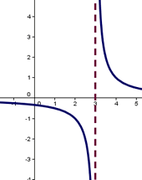

## Lola Tries

1. 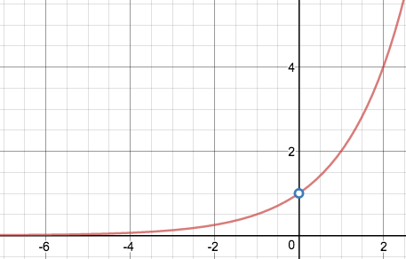On the graph to the right, what is ?
2. On the graph to the right, what is ?
3. On the table below, what is the?

|  |  |
| --- | --- |
| x | f(x) |
| 1.9 | 4.9 |
| 1.99 | 4.99 |
| 2 | 17 |
| 2.1 | 4.99 |

Next Stop: Costa Rica

# Welcome to Costa Rica!

Bienviendo a Costa Rica!

How do I evaluate limits algebraically? 

We have the basic skills and understanding to move into the next major part of evaluating limits: how to evaluate limits algebraically. All of previous concepts we have learned are still in play when we evaluate limits algebraically, we are just adding one more tool for evaluation.

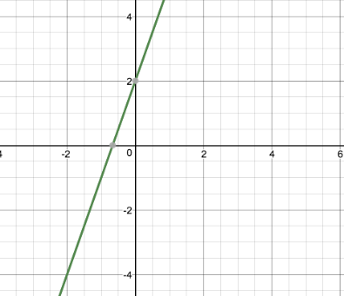 To find the limit for any continuous function, we use substitution. For example, if we have the function and we wanted to know the , we would simply substitute x=-2 into f(x). Therefore, . We can see that this is in fact the case when we view the graph of f(x). If we evaluate the limit from the graph of f(x), we can see that the is indeed, -4. There are two major exceptions to the substitution rule. The first exception is when substitution yields , where c is any constant. We will get to this exception in a later section!

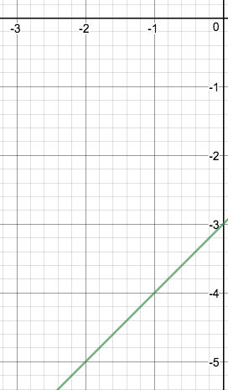 The second exception is when substitution yields the indeterminate form, . In this case, we will need to change the form of the function using various algebraic techniques in order to evaluate it. For example, if we had the function , and if we wanted to know the , we would first use substitution: . We now must use algebraic techniques to manipulate the function into something that we can work with. Since the top is a quadratic function, a good first step may be to factor it. . We can change the numerator to this, so that we now have . Since there is a (x+2) on both the top and the bottom, we can cancel, so that we have . Finally, we can substitute -2 in for x to evaluate the limit. . We can see from the graph of the function that .

## Guided Practice

1. What is the ?
   1. The first thing one should try doing is substitution. With substitution we yield . Since we got the indeterminate form, we know we must use some algebraic manipulation to successfully solve the limit. The first thing to do is factor the quadratic in the denominator of the second fraction. We would then have . Now, we can try to combine the two fractions into one. We need to have a common denominator. The common denominator can be (x)(x+1). The first fraction is missing an x+1, so we would multiply the numerator and denominator of the first fraction by x+1 to get . Since we have an x on both the numerator and denominator, we can cancel them to get . We have algebraically manipulated the limit so that we are finally able to use substitution. Now we can substitute 0 for x to get . So the .
2. What is the ?
   1. The first thing one should try is substitution. With substitution we yield = 0. Since substitution worked, we are done! =0!

## Lola Tries

1. What is the ?
2. What is the ?
3. What is the

Next Stop: Panama

# Welcome to Panama!

La bienvenida a Panamá!

How do I use limits to determine vertical asymptotes? 



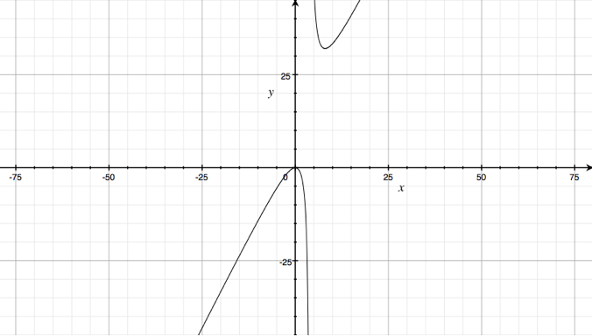 The first exception to using substitution is when substitution yields , where c is any constant. Any limit resulting in will have a limit equal to or DNE. For example, if we had a function, and we wanted to know the , we would first try to use substitution. . Since substitution did not work, we would look at the limit from either side of x=4. To evaluate the limit from the left of x=4, we would plug in a number that is a bit smaller than x=4. We would indicate this by . We would then see if the numerator is positive or negative if we plugged in a number a bit smaller than 4. Then we would see if the denominator is positive or negative if we plugged in a number a bit smaller than 4. Lastly, we would see if the overall limit from the left is positive or negative. If the limit is negative, then the . If the limit is positive, then the .Now we are ready to evaluate the limit from the left: . When we substituted a number smaller than -4, we yielded a positive numerator and negative denominator. Since a positive divided by a negative is a negative, we know that the . Great! We are now halfway done. In order to evaluate the overall limit, we must look at the limit from both sides. We will now look at the limit as x approaches 4 from the right. To evaluate the limit from the left of x=4, we would plug in a number that is a bit larger than x=4. We would indicate this by . We would then follow the same steps that we did when evaluating the limit from the left. The limit as x approaches 4 from the right: . Now that we know the limit from both the left and the right side, we can determine the overall limit. Since the limit as x approaches -4 from the left is and the limit as x approaches -4 from the right is , the overall limit does not exist, as the limit from the left does not match the limit from the right. If we were to evaluate the limit from the graph of f(x) as we did in the last section, we would see that .

## Guided Practice

1. What is the ?
   1. The first thing one should try doing is substitution. With substitution we yield . Since we got a constant over 0, we know that the limit will evaluate to or DNE. This is an indication that we must look at the limit from both sides. The limit from the left: The limit from the right: . Since the limit from the left does not equal the limit from the right, the overall limit does not exist. So
2. What is the ?
   1. The first thing one should try doing is substitution. With substitution we yield . Since we get a constant over 0, we know the limit will evaluate to or DNE. This is an indication that we must look at the limit from both sides. The limit from the left . The limit from the right: . Since the limit from the left does not equal the limit from the right, the overall limit does not exist. So

## Lola Tries

1. What is the ?
2. What is the ?
3. What is the ?

Next Stop: Brazil

# Welcome to Brazil!

Bem vindo ao Brazil!

What are limit laws?

There are laws for limits?! Absolutely! What are they? Limit laws are essentially shortcuts to evaluate certain limits. The first four limit laws have to do with limits of two functions. Let’s dive right in!

1. Suppose that c is a constant and the limits and exist, then
   * If we are to take the limit of f(x) plus g(x) approaching “a”, then we are able to evaluate the limit as f(x) approaches “a” and g(x) approaches “a”, separately, and simply add them together.
   * If we are to take the limit of f(x) minus g(x) approaching “a”, then we are able to evaluate the limit as f(x) approaches “a” and g(x) approaches “a”, separately, and simply subtract them.
   * If we are to take the limit of f(x) times g(x) approaching “a”, then we are able to evaluate the limit as f(x) approaches “a” and g(x) approaches “a”, separately, and simply multiply them together.
   * If we are to take the limit of f(x) times g(x) approaching “a”, then we are able to evaluate the limit as f(x) approaches “a” and g(x) approaches “a”, separately, and simply divide them.

The next seven limit laws deal with other limit situations, but we keep the assumption that c is a constant.

* + If we are to take the limit of f(x) as it approaches “a”, but f(x) is multiplied by some constant, we can take the constant out and evaluate the limit of f(x) as it approaches “a” normally, but multiply the limit by the constant at the end.
  + If we are to take the limit of f(x) as it approaches “a”, but it is raised to the nth power, we can simply take the limit of f(x) as it approaches “a” normally, and then raise our result to the nth power. In this situation, it is important to remember that n must be a positive integer.
  + The limit of any constant as it approaches “a” is just the value of that constant.
  + The limit of the function, y=x, as it approaches “a”, is just the value of “a”, the value that the function is approaching.
  + The limit of the function, x raised to the nth power, as it approaches “a”, is just “a” raised to the nth power. Again, we must remember that n will have to be a positive integer.
  + The limit of the function, the nth root of x, as it approaches “a”, is just the nth root of “a”. Not only does n have to be a positive integer, if it is even, we must assume that a>0.
  + If we are to find the limit of the function, the nth root of f(x), as it approaches “a”, we find the limit as f(x) approaches “a” like normal, and then take the nth root of our result.

## Guided Practice

1. 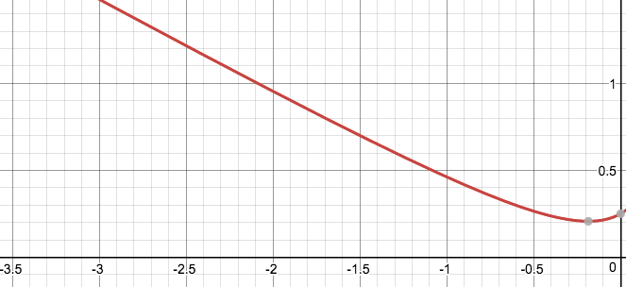What is ?
   1. The first thing we can do is identify that this would be a situation in which we could use limit laws, even though it may not look like it! We can define the numerator as f(x), and the denominator as g(x). Now we know we can use limit law #4 to evaluate this situation. We first take the limit of the numerator. We can simply use substitution in this situation. = 21. Next we take the limit of the denominator, using substitution. . We can determine the overall limit now. We take the limit of the numerator (21) and divide it by the limit of the denominator (22) to get the overall limit as 21/22. So, !
2. If we know that the limit of f(x) as it approaches 2 is 5 and the limit of g(x) as it approaches 2 is 2, what is ?
   1. In this situation, there are multiple limit laws going on! We know that when we are taking the limit of two functions added together, we can look at them as separate limits and then just add them together according to limit law #1. So let’s focus on the first function, f(x). Limit law #6 tells us that we can simply take the limit of f(x) as it approaches 2 first, then square it. We know that the limit of f(x) as it approaches 2 is 5, and if we square that it is 25. Great! We can now look at the g(x) part. In this situation, x is multiplied by g(x) squared. x is a constant because it is just an x-value. In this situation, x would be 2 because we are approaching 2 for our limit. Using limit law #5, we know we can simply multiply this constant by the limit of g(x) squared as it approaches 2. Since g(x) is squared, we must use limit law #6 again and take the limit of g(x) as it approaches 2 separately and then raise it to the second power. The limit of g(x) as it approaches 2 is 2, and if we square that it is 4. We must remember to also multiply that by the constant, 2. So the limit for that section of the overall limit is 8. When we take the limit of two functions added together, we simply add the component limits. The first section gave us 25 and the second section gave us 8, so 25+8 = 31. So, .

## Lola Tries

1. Let and . What is ?
2. What is the ?
3. What is the ?

Next Stop: Peru

# Welcome to Peru!

La bienvenida a Perú!

How do I use limits to determine horizontal asymptotes?

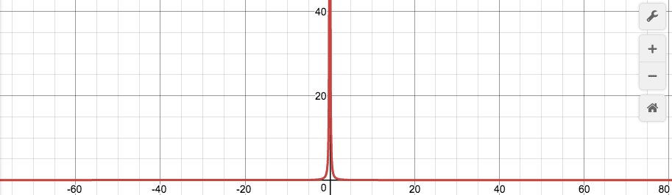Before we can use limits to determine horizontal asymptotes, we must first understand what a horizontal asymptote is! A horizontal asymptote exists if or , where L is just a constant. On the graph to the right, , a horizontal asymptote exists at y=0, because as the x values get closer and closer to infinity and negative infinity, the y-value gets closer and closer to 0, as the denominator is getting smaller and smaller.

Now we are ready to use limits! There is an important theorem to remember when using limits to determine horizontal asymptotes. If r>0 and r is a rational number, then and . This can be especially useful in determining limits to infinity for fractions, as we can multiply the numerator and denominator by 1 over x raised to the highest power, and a lot of the components of the limit will go to zero.

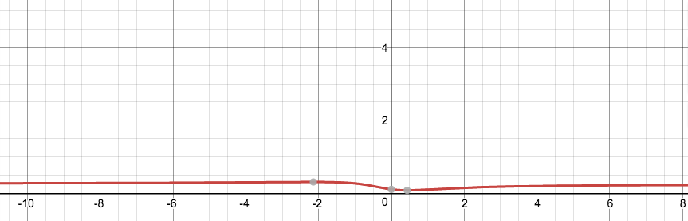For example, if we wanted to evaluate the following limit; , we would start by identifying the highest power. The highest power in this limit is 2. So we would multiply both the numerator and denominator by . We can start by dividing each component of the polynomial in the numerator by . , , as there is a higher power on the denominator than the numerator, and , for the same reasoning as the previous component. So on the numerator, we are left with only a 2. We would do this same process on the denominator. , , and . So on the denominator, we are left with only 8. We are left with the fraction . Therefore, . We can see this by examining the graph to the left. As the x values get larger and larger towards infinity, the y values are getting closer and closer to ½ .

## Guided Practice

1. What is the ?
   1. First, we must identify the highest power in the whole fraction. The highest power is Therefore, we would multiply both the numerator and denominator by When multiplying it to the numerator, we must multiply it by , as it’s being multiplied under square root, and . We would multiply to every component of the polynomial under the square root. In doing so, we would only be left with the on the numerator, because is a higher power than , or a constant, so those two limits would go to zero, and , but we have to take the square root of 4, which is 2. Then, we would multiply to the denominator, to get just 30 on the denominator, because is a higher power than just x, and so that limit would go to zero, and . Thus, our overall limit would go to . Thus
2. What is ?
   1. Though this does not look like a fraction right now, we can easily make it one by multiplying by a conjugate on both the numerator and denominator. In this case, the denominator is 1. Once we multiply by a conjugate () and simplify on the numerator, we are left with . The highest power in this instance would be . We must multiply to both the numerator and denominator. When we multiply it to the numerator, we get . On the denominator, we must multiply the inside of the radical by , as . Once we do so, we get a from the piece of the denominator inside of the radical, as is a higher power than x, and so that limit goes to zero, and , but we have to take the square root of 25, which is 5. Lastly, we take care of the 5x that is added outside of the radical. We multiply this by to get 5, as . So we are left with an 8 on the numerator and a 5+5=10 on the denominator, so our overall limit evaluates to . Thus, .

## Lola Tries

1. What is ?
2. What is ?
3. What is ?

Next Stop: Argentina

# Welcome to Argentina!

La bienvenida a la Argentina!

How can I use limits to prove continuity at a point?

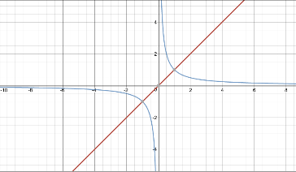A function is continuous when . In other words, a function is continuous at a given point, “a”, when the left-hand limit is equal to the right-hand limit and is equal to the value of the function at this point. For instance, the function , graphed in red on the right, is continuous, as there are no “breaks” in the function. The function , graphed in blue, is not at x=0 continuous, as there is a “break” at this point and the graph is separated into two different parts. There is a three-step proof in order to prove continuity at a point:

1. f(a) is defined
   * The original point must first exist before we can prove continuity! We know that f(a) is defined if “a” is in the function, f’s, domain. If f(a) did not exist, the right hand part of our definition for continuity () would not work.
2. exists
   * We must then prove that the limit exists. In order to prove that the limit as f(x) approaches “a” exists if the limit from the left side equals the limit from the right side. If did not exist, the left hand part of our definition for continuity () would not work.
3. * We must check if the value of f(a) from step #1 equals the limit as f(x) approaches “a”. If so, we have proven that f(x) is continuous at x=a.

For example, if , is f(x) continuous at x=-2? First, we must check if f(-2) exists, and what that value is. We know to use the top function because that piece of the function is defined when x is greater than or equal to -2. Thus, plugging in x=-2, we find that .

Now we must check if the limit exists, and if so, what the value is! The limit as x approaches -2 from the right is -4. The first piece of the piecewise function is when x is greater than or equal to 2, so we use this value for the limit as well; therefore, . Since the limit from the left equals the limit from the right, the overall limit exists at -4.

Since , both yield a y value of -4, f(x) is continuous at x=-2!

## Guided Practice

1. If , is g(x) continuous at x=1
   1. First, we would find the value of g(x) at x=1, using the top part of the piecewise function. Using substitution, we find that g(1)= -2
   2. We know the limit as g(x) approaches 1 from the right is -2, as we would substitute 1 into the top part of the piecewise function as we did in part a. Now we must find the limit from the left, substituting 1 into the bottom part of the piecewise function. . Since the limit from the left does not equal the limit from the right, we can stop there because the right hand side of the definition of continuity is not met. Therefore, g(x) is not continuous at x=1.
2. For , find a value of c to make f continuous at x=2.
   1. To solve this, we must understand that in order for continuity to occur, the limit from the left and the right must match and f(a) must exist. For the limits to match however, . Using this piece of knowledge, we can solve for c. We know x=2, so . Thus, c must equal 5/2 for f(x) to be continuous at x=2.

## Lola Tries

1. If ; is f(x) continuous at x=4?
2. Find the values of a and b to make the function continuous:
3. If is f(x) continuous at x=2?

Next Stop: South Africa

# Welcome to South Africa!

Ukuwamukela eNingizimu Afrikha!

What are the different types of discontinuity and how do I identify them?

Now that we know when a function is continuous, it is important to explore when and how a function is discontinuous! There are three major ways that a function can be discontinuous.

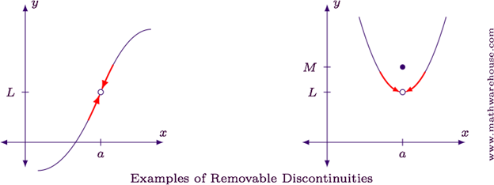The first type of discontinuity is removable discontinuity. Removable discontinuity occurs at holes. In the example shown on the right, there is a hole on both graphs at x=a. In these cases, the limit as x approaches “a” always exists, but it’s discontinuous because f(a) either doesn’t exist, as shown on the graph to the left, or the limit as x approaches “a” does not match the point at x=a, as shown on the graph to the right! A hole exists when the limit as x approaches “a” upon substitution yields .

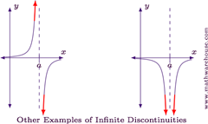The second type of discontinuity is infinite discontinuity. Infinite discontinuity occurs where there is a vertical asymptote. A limit may or may not exist depending on the situation, but f(a) never exists. With infinite discontinuity, either the limit as x approaches “a” from the right, left, or both, must be . In the example to the left, there is infinite discontinuity in both graphs at x=a because a vertical asymptote exists and the limit as x approaches “a” for both graphs is . In the graph to the left, a limit does not exist because one side of the graph goes towards and the other side goes towards at x=a. In the graph to the right, a limit does exist because both sides of the graph are going towards . We know that infinite discontinuity exists when the limit as x approaches “a” upon substitution yields .

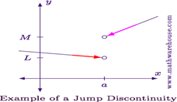The last type of discontinuity is jump discontinuity. Jump discontinuity exists when the limit as x approaches “a” from the right does not equal the limit as x approaches “a” from the left. In other words, the limit as x approaches “a” does not exist. There may or may not be a point at x=a, depending on the situation. In the example shown to the right, jump discontinuity exists because the limit does not exist at x=a. Be wary though, do not get this confused with infinite discontinuity. Sometimes in infinite discontinuity, the limit does not exist either, however with infinite discontinuity, there is always a vertical asymptote.

## Guided Practice

1. Let’s revisit question #1 from our guided practice in the last section. We found in the last section that g(x) is discontinuous at x=1, but what kind of discontinuity is it?
   1. 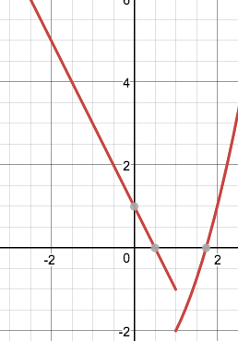We found that the limit as x approaches 1 from the left does not equal the limit as x approaches 1 from the right. That eliminates removable discontinuity, because in removable discontinuity, the limit always exists. We are then left with jump discontinuity and infinite discontinuity. With infinite discontinuity, either the limit from the left or the limit from the right must be . The limit from the right was -2 and the limit from the left was -1, neither of which is . Using process off elimination, we can conclude that it is jump discontinuity.
2. 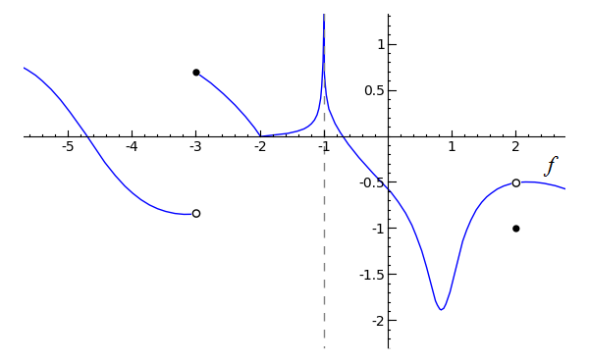Using the graph to the right, f(x), state the x values f(x) is discontinuous, the type of discontinuity, and explain why.
   1. x=-3, jump discontinuity, as the limit from the left does not equal the limit from the right, and neither the limit from the left nor from the right is approaching positive or negative infinity.
   2. x=1, infinite discontinuity, as the limit from both sides is approaching positive infinity.
   3. x=2, removable discontinuity, as f(2) does not match the limit at that point.

## Lola Tries

1. 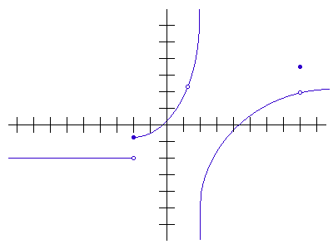What type of discontinuity, if any, exists for the function, at x=0?
2. For the graph to the right, f(x), state the x-values at which f is discontinuous and the type of discontinuity.
3. For the function at what x values, if any does discontinuity occur, and what type?

Next Stop: Madagascar

# Welcome to Madagascar!

Welcome to Madagasikara!

What is the Intermediate Value Theorem?

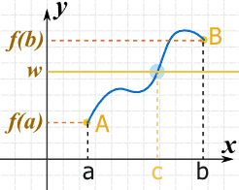

The Intermediate Value Theorem tells us that if we are given a continuous function f defined on the closed interval [a,b], for any real number d between f(a) and f(b) there exists a point c between a and b such that f(c)=d. If we look at the graph on the right, we can see the Intermediate Value Theorem in action.

The graph shoes a continuous function, f. We know that the function is continuous because there are no “breaks” in the graph. We also have a closed interval [a,b], because the graph starts at a, and ends at b. and the point (a, f(a)) exists, and so does the point (b, f(b)). In between the x-values a and b, there is an x-value, c, in which f(c), which is defined as w on the graph, exists.

Imagine you and your friend want to stretch a single piece of rope from North Carolina to California. In order to do so, the rope has to travel through other states like Kansas, Nevada, etc. It can’t just magically appear in California, because it is a continuous piece of rope. Similarly, with the Intermediate Value Theorem, if you want to go from point a to point b, you must first pass through a point in the middle, point c.

The Intermediate Value Theorem is especially useful in finding whether a continuous function has a zero, or if a certain y-value exists on an interval.

For example, if we had the function , will the function have a zero on the interval ? We can use Intermediate Value Theorem to easily solve this problem. We know that the function is continuous, as both the sine and cosine functions are continuous. Then, we can find the y-values of our endpoints. , . We know that zero is between -1 and 1, and the graph is continuous, so there is a point on the graph in which f(c)=0! Therefore, by IVT, since f(0)<0<f() , there exists a “c” such that 0<c<, where f(c)=0. In other words, there is a place in the function, on the specified interval, where f(c)=0.

## Guided Practice

1. Determine if your oven is at 350°, as it cools down before turning it off, at some instant must its temperature be exactly 170°?
   1. We know that temperature is a continuous function, as it decreases slowly and fairly steadily. It will turn off at room temperature, which is approximately 70°. Temperature is a function of time. We can define time “0” as when the oven begins to cool off. Time is infinite, so the interval begins at 0, and ends at “infinity.” Now, we have enough information to solve the problem. Since temperature is a continuous function, there exists a time “c” such that , and f(c)=170, because 70<170<350. The temperature we seek is between the temperature the oven starts at, and room temperature. The time at which the oven is 170° is between time 0, and infinite time, therefore IVT would apply.
2. Let h(x) be defined by on the interval [-3,2]. Is there a place in this interval where h(x)=0?
   1. We have a closed interval, but in order for this to be an IVT problem, we must first check if the graph is continuous. Since it is a piecewise function, we must check if the function is continuous at the break points. There is a break point at x=0. Using substitution on the first piece of the piecewise function, we get h(x)=1. Using substitution on the second piece of the piecewise function, we get h(x)=-1. Since 1 and -1 do not meet, the function is not continuous, therefore IVT would not apply. There is not guaranteed to be a place on the defined interval in which h(x)=0, because the function is not continuous.

## Lola Tries

1. If on the interval [1,2] is there a place between x=1 and x=2 where f(x)=0?
2. Does take on the value 0.4999 for some t in [0,1]?
3. Does a root exist on the interval [0, ] for the function ?

Next Stop: Kenya

# Image result for kenyaImage result for nairobi national parkWelcome to Kenya!

Karibu Kenya!

What is a derivative and the limit definition of a derivative?

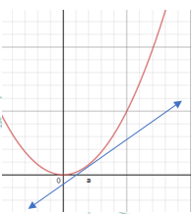Imagine a linear function, such as . What is the slope of this function? Well, we can determine that in several ways, whether it is the slope equation (, from the graph of the line, or the “m” value, as this function is in y-intercept form.

Now consider a nonlinear function, , shown to the right- what is its slope?

Since it is not a straight line, there is a different slope at every point along the function. How then would we find the slope at a specific point? One approach is to draw a straight line tangent to a given point, say, x = a. because we already know how to determine the slope of a straight line.

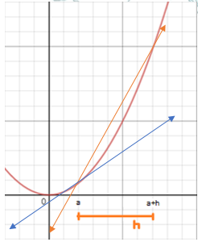Now all we have to do is determine the slope of this tangent line. It would be . But wait a second- that would yield ! Therefore, in order to use this slope equation, we need more points.  
Although it won’t be exact, we can approximate the slope at a given point using a secant line, which is drawn between two points, say at our original point, at , and a point units away horizontally, at . This would mean that our slope becomes .

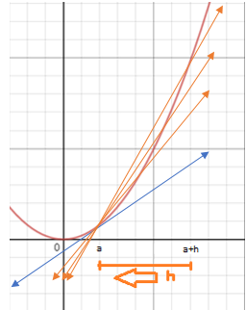However, we want to be as accurate as possible when determining the slope at a given point. Thus, we must move our secant line a little closer to the tangent line, by reducing the value of , and effectively bringing the point closer to a.

Technically, we could bring closer to for eternity! But that would take a little too long on the AP Exam.Instead, we can represent this mathematically as , because we reduce further and further to bring closer to . If we make smaller and smaller, approaching 0, this also means that our secant line approaches the tangent line. Thus, determining is the same thing as determining the slope for the tangent line at a given point- or as we’ll call it from now on, **the derivative!**

Now we can formally define that the limit definition of a derivative allows us to the instantaneous rate of change along a curve- i.e., the slope at a given point. Furthermore, we can notate this in two different ways; Newtonian notation and Leibnitz notation.

**Newtonian notation**:   
**Leibnitz notation:**

Let’s take a look at an example. Given a nonlinear curve like , what is the instantaneous slope at x = 1? I.e., what is ? Now it's easy to figure this out using the limit definition of a derivative! Based upon this definition, we can solve for .

So, to recap- *we just figured out the slope at a* ***specific*** *point on a* ***nonlinear curve****!* But we can go even farther. Imagine that you wanted to find the slope at multiple points, say, at on a more complex curve, like . With our new limit definition of a derivative, this might seem like a piece of cake at first- but it soon becomes difficult to quickly solve for all of these points! Instead, there is a better way- we can define a **derivative function**, which will tell us the derivative at any x value along the curve. How can we do this? Simply plug in “x”, representing any x-coordinate on our curve, into the limit definition of a derivative.

Thus, , and this will gives us the slope of at any point! This saves us tons of time- let’s try plugging in those points from earlier!

Clearly finding a derivate function makes more complex problem solving much easier.

Let’s try another example problem. Take a function , and we want to find . If we plug this into the limit definition of the derivative, we would find the following:

Woah! For some reason, it appears as if we cannot determine the derivative at for - you could even say that this function is **non-differentiable** here. It makes sense that this function is non-differentiable at if we look at a graph; there is a vertical asymptote at this point, meaning that we cannot even determine the value of the function at this point, let alone the instantaneous slope.

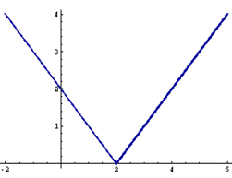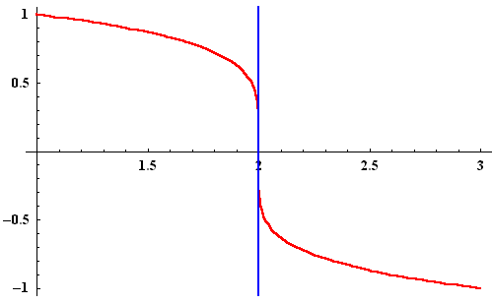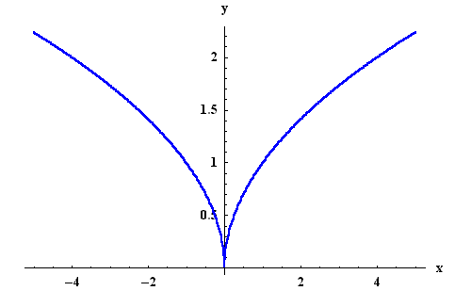This points to an important condition for differentiability; that the function must be continuous at a given point. However, there are two other states in which a function will not be differentiable. The first is when a corner or cusp occurs, shown on the right, where the slope of the function changes instantly. This means that there is a technically infinite number of possible slopes at that corner or cusp, making it impossible for us to determine a single slope at this point. The second time a function will be non-differentiable is when there is a vertical tangent, as shown on the left. This is because the derivative function will tend towards infinity, yet can never reach infinity, causing a vertical asymptote in the derivative function- making the derivative function discontinuous at the point of vertical tangency on the original function, and thus making the original function non-differentiable.

Corner

Cusp

## Guided Practice

1. Given , determine .
   1. asks for us to find the derivative, or the instantaneous slope, at x = 2 on . To find this, we can use the limit definition of a derivative. Therefore,   
      So, we found that the instantaneous slope at x = 2 is 0.
2. Given , what is ?   
   Remember that means the same thing as - thus, when this questions asks “what is ”, it is really asking for a function which gives the instantaneous slope at any value of x on . Therefore, we can solve this as follows:

## Lola Tries

1. 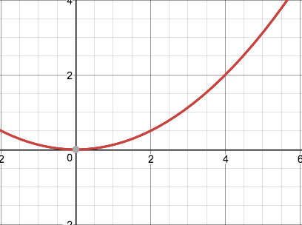From the graph of shown to the right, approximate by drawing a tangent line.
2. Given , what is ?
3. Given , what is ?

Next Stop: Nigeria